Global-Scale Coupling Characteristics between Geomagnetic Storms and Ionospheric Disturbances

Nisong Pei(https://orcid.org/0000-0008-1234-0000)^{a,b}, Yong Wu(https://orcid.org/0000-0008-1234-0001)^{a,}*, Rui Su(https://orcid.org/0000-0008-1234-0000)^{c}, Jianfeng Li(https://orcid.org/0000-0008-1234-0000)^{d}, Yongqian Wang(https://orcid.org/0000-0008-1238-1222)ª, Xueling Li(https://orcid.org/0000-0008-1234-0004)ª, and Zhenghao Wu(https://orcid.org/0000-0008-1234-0040)ª

ªCollege of Environment and Civil Engineering, Chengdu University of Technology, Chengdu, China
^{b}College of Resource and Environment, Chengdu University of Information Technology, Chengdu, China
^{c}Beijing Institute of Geology of Nuclear Industry, Beijing, China
^{d}Sichuan Academy of Safety Science and Technology, Chengdu, China
*e-mail: ywu@cdut.edu.cn

Abstract—To explore the global-scale coupling characteristics between ionospheric disturbances and geomagnetic storms, and research the near-Earth space environment, the time synchronization, correlation, and fitting relationship of geomagnetic field and ionosphere are analyzed in 78 geomagnetic storms from 2013 to 2017. Simultaneously, to improve the accuracy of ionospheric disturbance monitoring, a method for detecting ionospheric disturbances based on wavelet transform is proposed. Results show that the signal noise of global electron content is abnormally enhanced in 76% of the geomagnetic storm events, and the abnormal period coincides with the fluctuation period of the geomagnetic index. Two parameters, named Match and non-Match, are proposed to quantify the time synchronization between geomagnetic storms and ionospheric disturbances, it is found that a high synchronization exists between the two. The weighted polynomial function model, which used the ionospheric and geomagnetic parameters, is established. The fitting results show a significant functional relationship between the two, indicating that geomagnetic storm has a significant effect on ionospheric disturbance. The T-test results indicate a significant correlation between the fitted function and the measured data in 86% storm events.
Keywords: geomagnetic storm; ionospheric disturbance; global-scale coupling characteristics; quantify synchronization; weighted polynomial function

1. INTRODUCTION
Strong geomagnetic storms are often accompanied by the generation of ionospheric disturbances. Many studies have explored the response of ionosphere to geomagnetic field disturbance during a specific geomagnetic storm (Ding et al., 2007; Perevalova et al., 2008; Adekoya et al., 2012; Simi et al., 2013; Song et al., 2013; Jin et al., 2017; Yang et al., 2018). Notably, typical ionospheric disturbances, the same as geomagnetic storms, also undergo stages of primary phase, main phase, and recovery phase (Adekoya et al., 2012; Li et al., 2016). Magnetosphere-Ionosphere (M-I) coupling is confirmed by extensive research but not fully understood yet. Studying the coupling characteristics of geomagnetic field and ionosphere during geomagnetic storms is of great significance for ionospheric physics, electromagnetic wave refraction correction, ionospheric model research and detecting the Earth's space environment.
<…>
The commonly used ionospheric parameter TEC has local characteristics and cannot sufficiently describe the global ionospheric disturbance. Afraimovich et al. first introduced the concept of global electron content (GEC) in 2006 and applied it to ionospheric climatology (Afraimovich et al., 2006). They found that the change in GEC has a coupling relationship with solar ultraviolet irradiance and F10.7 index (Afraimovich et al., 2006; Afraimovich et al., 2008). She et al. (2008) used GNSS TEC data with a geographical longitude of 120°E to obtain meridional GEC and analyzed its coupling with solar radiant flux F10.7 and its seasonal correlation. They found that meridional GEC is closely related to solar activity flux F10.7 and its seasonal correlation. Gulyaeva and Veselovsky (2012) discovered the analysis model of typical GEC storm profile by analyzing 10 geomagnetic storms during 2001–2011 and found that GEC depletion and solar wind speed decrease when magnetospheric ring-current and ionospheric auroral electrojet recover. Yenen et al. (2015) found that Storm time modeling of GEC calculated from GIM-TEC for 1999–2013 is associated with new proxy of Auroral Electrojet variability expressed as a smoothed and normalized Auroral Electrojet index (AE), and the positive correlation between the increase of AE and GEC can be a promising precursor of space weather variability. Li et al. (2016) analyzed the changes in GEC during magnetic storm events and found that the GEC/GEC_{QT} (GEC_{QT} is GEC at quietest day in a month) ratio is closely related to the geomagnetic Kp index and the time-weighted Dst index. They also established a linear model of GEC storm time response.
GEC can reflect the changing characteristics of the ionosphere and plasmasphere on a global scale, and GEC is affected by many factors, such as solar activity, geomagnetic activity, and seasonal changes. However, the above research is mainly about specific storm events or a specific region. To explore the coupling characteristics between the ionosphere and the geomagnetic field during geomagnetic storms, this study uses statistical methods to study many geomagnetic storm events from 2013 to 2017, and analyzes the synchronicity, correlation, and function fitting relationship between the two on a global scale.

2. DATA AND METHODS

According to Afraimovich et al., the GEC is obtained from global ionosphere maps (GIMs). The GEC is calculated by summation of TEC values in each GIM cell, as shown in Eq. (1) (Afraimovich et al., 2006). To date, many products for ionospheric GIM are available, such as CODE (Center for Orbit Determination in Europe) GIM, ESA (European Space Agency) GIM, JPL (Jet Propulsion Laboratory of American) GIM, UPC (Polytechnic University of Catalonia) GIM and WUH (Wuhan University) GIM. This study uses GIM products from the CODE (ftp://cddis.gsfc.nasa.gov/pub/gps/products/ionex/).
$\left\{\begin{aligned}&GEC=\sum_{m,n}{ TEC_{m,n} S_{m,n}} \\ &S_{m,n}=R_{E}^{2}Δϕ[\sin{θ_{n}}-(\sin{θ_{n}}+Δθ)]\end{aligned}\right.$, (1)
where TEC is the vertical TEC value of the GIM grid, unit: TECU (1 TECU = 1 × 10¹⁶ electron/m³); GEC is global electron content, unit: TECU (1 TECU = 1 × 10³² electron/m³); m and n are the GIM cell index; $Δϕ$ and $Δθ$ are the GIM grid latitude and longitude range, respectively; and R_{E} is the spherical shell radius of the ionospheric single-layer model, unit: km (Afraimovich et al., 2006; She et al., 2008; Li et al., 2016). In the approximate case, the ionospheric single-layer model can be regarded as a spherical shape, and the spherical shell height of 400 km can obtain the best effect (Afraimovich et al., 2008).
To describe and compare the changes of the ionosphere and the geomagnetic field during the storms, the two parameters of the rate of GEC change (RGEC) and the rate of average geomagnetic intensity change (RAGI) are defined. RGEC is defined as the ratio of GEC observations to GEC_{QT} which is the GEC of the quietest day of geomagnetic activity for the month. RAGI is defined as the ratio of the global averages of the geomagnetic intensity components, which are X, Y, Z and F, to the ones which are the quietest day of the geomagnetic activity of the month, as shown in Eqs. (2) and (3):
$RGEC=\frac{GEC}{GEC_{QT}}$, (2)
$\left\{\begin{aligned}&{RAGI}^{\overline{C}}=\frac{\overline{C}}{{\overline{C}}_{\text{QT}}} \\ &\overline{C}=\frac{1}{n}\sum_{i}^{n}{C_{i}}\end{aligned}\right.$, (3)
where C is the geomagnetic component expressed in nT, n is the number of geomagnetic monitoring stations. GEC_{QT} and C_{QT} represent GEC and geomagnetic components of the quietest day, respectively. RGEC and RAGI have no units and can easily compare the changes of GEC and geomagnetic intensity under different geomagnetic storm levels.
<…>
To make the discussion statistically significant, we selected in this study 78 geomagnetic storm events in 2013–2017 as the research object, the Dst index is used to judge the start and end time and intensity of geomagnetic storms. The Dst index, Kp index, and geomagnetic quiet day data came from the International Service of Geomagnetic Indices (http://isgi.unistra.fr/data_download.php). The geomagnetic storm intensity judgment standard is shown in Table 1 (Palacios et al., 2017). When the minimum value of the Dst index is less than –50 nT (or the Kp is more than 5), a geomagnetic storm is considered to occur. An intense storm is happening when the minimum value of the Dst index is less than –100 nT (or the Kp is 7 to 9). Among the 78 geomagnetic storms, 13 were intense storms, and the remaining 65 were moderate storms.

3. RESULTS AND ANALYSIS

3.1. Storm Time Synchronization Analysis
This section may be divided by subheadings. It should provide a concise and precise description of the experimental results, their interpretation as well as the experimental conclusions that can be drawn.
To explore the synchronization degree of ionospheric disturbances and geomagnetic storms, the start and end time of the ionospheric disturbances is determined by GEC fluctuation trend. Li et al.’s research shows that GEC exhibits continuous abnormal fluctuations during geomagnetic storms and its positive and negative phases are observed (Li et al., 2016). Therefore, the positive phase start time and negative phase end time of the GEC can be used to judge the duration of the ionospheric disturbances. However, not all storms exhibit significant positive and negative phase changes in GEC, especially in strong storms, where GEC exhibits continuous abnormal fluctuations.
Therefore, this study proposed a method for judging the ionospheric disturbance by the GEC noise which it was separated from GEC signals with wavelet transform. Wavelet transform is a time-frequency analysis method, assuming that the signal $x\left(t\right)$$x(t)$ is a square integrable function, then the wavelet transform of $x\left(t\right)$$x(t)$ is the inner product of the signal itself and the wavelet function $Ψ_{s,t}(t)$$Ψ_{a,b}(t)$:
$W_{f}\left(s,t\right)=\frac{1}{\sqrt{|s|}}\int{x\left(t\right)Ψ^{*}\left(\frac{t-T}{s}\right)dt=\left[x\left(t\right),Ψ_{s,t}(t)\right]}$$W_{f}(a,b)=\int{x(t)Ψ_{a,b}(t)}dt$. (4)
In addition, the signal can be reconstructed by inverse wavelet transform:
$y=C_{Ψ}^{-1}\iint{(y,Ψ_{a,b})Ψ_{a,b(t)}\frac{da*db}{a^{2}}}$$x(t)=C_{Ψ}^{–1}\iint{W_{f}(a,b)}Ψ_{a,b}(t)\frac{da db}{a^{2}}$, (5)
where $Ψ_{s,t}(t)$$Ψ_{a,b}(t)$ is the wavelet transform function; $a$ is the scaling factor; $b$ is the smoothing factor, $t$ is the time; $C_{Ψ}$$C_{Ψ}$ is the admissibility condition of wavelet. The wavelet transform analyzes the signal by the expansion and contraction translation of $Ψ\left(t\right)$$Ψ(t)$ in time and frequency. A choice of the appropriate wavelet basis function (WBF) and order is the key to wavelet transform. The experiment found that using the fifth-order dmey WBF can well separate the trend form the GEC time series signal, so as to obtain GEC noise. The dmey is a type of WBF called DMeyer. To determine the frequency (or temporal scale) contents of a signal and how they vary with time, which the purpose of can be achieved by scaling and transforming the WBF (Sang et al., 2013).
Through the wavelet transform of the GEC, it was found that the noise signal separated from the GEC signal is severely disturbed during the geomagnetic storms. The amplitude of noise is increased to ±2 GECU (1 GECU = 1 × 10³²), which is about 1% of GEC, indicating that GEC noise enhancement is obvious, as shown in Figs. 2 and 3.
In an intense storm (Fig. 2), the Kp index increased sharply from 7:00 am UT on March 17, 2015. Moreover, the Dst index showed a sudden drop and continued until approximately 3:00 am on UT March 21, 2015，lasting about 92 h. The GEC noise (in Fig. 2c) also began to increase from approximately 5:00 am UT on March 17, 2015, lasting until around 6:00 am UT on March 18, 2015, about 25 h, and intermittent disturbance occurred in the following three days. The GEC signal (in Fig. 2d) is disturbed throughout the data phase after 5:00 am UT on March 17, 2015, but its positive and negative phase disturbance lasted until approximately 10:00 am UT on March 21, 2015, lasting about 53 h. Comparing Figs. 2c and 2d, it can be found that the positive phase of GEC signal corresponds to the severe disturbance period of GEC noise, and the GEC noise has stopped disturbance during the negative phase. It shows that when the driving force of ionospheric disturbance stops, the ionosphere will continue to disturb for a period of time.
In the medium storm (Fig. 3), from 6:00 am UT on October 2, 2013, the Kp (in Fig. 3a) and Dst (in Fig. 3b) indices both changed abnormally for approximately 9 h. At the same time, the noise signal (in Fig. 3c) of GEC showed an abnormal enhance, and the time of noise enhance is agree with that of Dst index less than –50 nT. The GEC signal (in Fig. 3d) began to rise from around 3:00 am UT on October 2, 2013, suddenly dropped from 9:00 am UT on October 2, 2013, lasting about 6 h, and then remained at a low level. It can be found that the sharp fluctuation time of GEC is earlier than the time of geomagnetic storm.
It was found through experiments that All 78 geomagnetic storms had abnormal GEC disturbances, but only some GEC disturbances satisfied the positive and negative phase characteristics. Significant noise anomalies were found in the GEC-filtered signal with only 59 storms, accounting for 76% of the total number of storms. Analyzing from the duration of the storm (yellow area), Fig. 2 shows that the GEC noise signal abnormal is discontinuous and the GEC disturbance is continuous, but their onset time is consistent with that of geomagnetic storm during a strong storm. Figure 3 shows that both the GEC disturbance and GEC noise signal abnormal are continuous, but their onset time is not consistent during a medium storm. In addition, both Figs. 2 and 3 show that the duration of ionospheric disturbance is longer than the duration of geomagnetic storm.
<…>
To quantify the degree of synchronization between geomagnetic storms and ionospheric disturbances, two parameters of “Match” and “non-Match” are defined. The “Match” is the ratio, wherein the overlapping part of the duration of the geomagnetic storm and the ionospheric disturbance is divided by the duration of the ionospheric disturbance. The “non-Match” is the ratio of non-overlapping part of the two to the duration of the ionospheric disturbance, as presented in Eq. (6):
$\left\{\begin{aligned}&M=\frac{T_{\text{covering}}}{T_{\text{ION}}}×100\% \\ &unM=\frac{T_{\text{uncovering}}}{T_{\text{ION}}}×100\%\end{aligned}\right.$, (6)
where M and unM represent the Match and non-Match, respectively. T_{covering} and T_{uncovering} respectively indicate the overlap time and non-overlap time of geomagnetic storm and ionospheric disturbance. T_{ION} indicates the duration of the ionospheric disturbance. As can be seen, the larger the M, the higher the synchronization degree of the two, and the smaller the unM, the higher the synchronization degree. Time synchronization of all 78 storm events is analyzed, however, only the Match and non-Match values for 18 storms in 2013 are listed as a representative sample in Table 2 due to space limitations.
In Table 2, en dashes indicate no abnormal signal of GEC noise is observed, and the strong storm events were marked in boldface. Statistics on the GEC noise of 78 geomagnetic storm events, it was found that about 76% of geomagnetic storm events detected GEC noise enhancement. The data in Table 2 shows that the duration of ionospheric disturbances judged by the GEC noise is more consistent with the geomagnetic storms than that judged by the GEC signal. However, the noise non-Match is higher than that of the signal, indicating that the GEC disturbance lasts longer. For the time synchronization analysis of all 78 storm events, the mean value of the Match is 48% for the GEC signal, and the mean value of non-Match is 51%. Moreover, the mean value of the Match is 67% for the GEC noise, and the mean value of non-Match is 41%. It indicates that the duration of ionospheric disturbances obtained by the GEC noise has high synchronism with the duration of geomagnetic storms. It also shows that the geomagnetic storms and ionospheric disturbances have a coupling relationship in duration.

3.2. Correlation Analysis
The correlation between the geomagnetic field activity indices and the ionospheric GEC during geomagnetic storms is direct evidence of the coupling relationship between the geomagnetic storms and ionospheric disturbances. Geomagnetic indices are often used in historical studies to reflect changes of the geomagnetic field, but common geomagnetic indices have limitations when characterizing the geomagnetic field fluctuations.
<…>
Studies have shown that ionospheric anomalies are not only related to the geomagnetic field disturbances, but also related to solar activity (Afraimovich et al., 2006; She et al., 2008; Gulyaeva and Veselovsky, 2012). Therefore, it is believed that ionospheric anomalies may be caused by several factors such as geomagnetic storms and solar activity, and the influence of geomagnetic field can be subdivided into the influence of different geomagnetic components. Therefore, F10.7 index, used to measure the intensity of solar activity, the global average of the geomagnetic components of X, Y, Z and total field F, and the rate of average change in the geomagnetic components (R_{X}, R_{Y}, R_{Z}, and R_{F}) were used in the experiment. The ionospheric disturbance was provided by two parameters, namely, GEC (from Eq. (1)) and RGEC (from Eq. (2)). The partial correlation between the two ionospheric parameters and the eight geomagnetic parameters, one solar activity parameter was studied respectively. Under the influence of multiple factors, a partial correlation will fix the other influencing factors and reflect the correlation strength of a single factor. Therefore, the partial correlation of geomagnetic parameters rules out the effects of solar activity. From the experimental results, the partial correlation coefficients of different storm events vary greatly. The maximum value of the eight partial correlation coefficients for geomagnetic parameters is considered as a measure of the correlation between geomagnetic storm and ionospheric disturbance. The maximum partial correlation coefficients of 78 storms were obtained, and its bar graphic was shown in Fig. 4. The partial correlation coefficient of the F10.7 index was regarded as the correlation between the solar activity and the ionospheric disturbance, as shown in Fig. 5.
<…>
In summary, there is a significant correlation between ionospheric parameters and geomagnetic parameters during most geomagnetic storms. However, for different geomagnetic storm events, there is a difference in the positive and negative characteristics of the correlation.

3.3. Function Fitting Analysis
It can be known that the correlation between the ionospheric parameters (GEC/RGEC) and the geomagnetic parameters (X, Y, Z, F, R_{X}, R_{Y}, R_{Z}, and R_{F}) is significant during geomagnetic storms. Therefore, with the hypothesis that geomagnetic storms are the main influencing factor on ionospheric disturbances, the following is a discussion of whether a functional relationship exists between the ionosphere and the geomagnetic field. A weighted polynomial function model between the two ionospheric parameters and the above eight geomagnetic parameters is established. The model is shown in the equation
$\left\{\begin{aligned}&Y^{M}=\sum_{i=1}^{8}{A_{i} P_{i}^{M} X_{i}} \\ &P_{i}^{M}=\frac{ρ_{i}^{M}}{\sum_{i=1}^{8}{ρ_{i}^{M}}}\end{aligned}\right.$, (7)
where M stands for GEC or RGEC, A_{i} is the model coefficient, and X_{i} is the geomagnetic parameters, P_{i} represents the weight coefficient of geomagnetic parameters, and $ρ_{i}$ represents the partial correlation coefficient between geomagnetic parameters and ionospheric parameters. When constructing a functional model, a large weight should be assigned to the parameters with a large correlation, and conversely a small weight to the parameters with a small correlation. The functional model illustrated in Eq. (5) was used for polynomial fitting analysis of 78 storm events. The time resolution of the ionosphere and geomagnetic parameter data is 1 h. The time resolution of the ionosphere and geomagnetic parameter data is 1 h. Figure 6 is a bar graphic of correlation coefficient between the fitted function and the observed data.
<…>
In the experiment, large differences of fitting relationship were observed in the weighted polynomial function models of different storms. This finding showed that the storm events have different characteristics; using a single function to fit all storms is difficult. Therefore, two strong storm events and two medium storm events were randomly selected to analyze the fitting results. The information of four storm events is shown in Table 4, and the curves of fitting function and the measured data points are drawn, as shown in Figs. 7 and 8.
<…>

4. CONCLUSIONS
This study analyzes the time synchronization, correlation, and function fitting relationship between ionospheric disturbances and geomagnetic storms in 78 geomagnetic storm events from 2013 to 2017, in order to explore the coupling characteristics of geomagnetic storms and ionospheric disturbances on a global scale. The following conclusions were obtained.
(1) The GEC noise was separated from the GEC by wavelet transform. The GEC noise was enhanced during the geomagnetic storms, and the enhanced period coincided well with that of the geomagnetic index disturbance. <…>
(2) Two parameters, Match and non-Match, were defined to quantify the degree of time synchronization between the geomagnetic storms and the ionospheric disturbances. <…>
(3) By defining the rate of average geomagnetic intensity change, the partial correlation coefficients between the ionospheric parameters (GEC and RGEC) and nine parameters (eight geomagnetic parameters and one solar activity parameter) were analyzed. <…>
(4) The weighted polynomial function model between the ionospheric two parameters (GEC and RGEC) and the eight geomagnetic parameters (X, Y, Z, F, R_{X,} R_{Y}, R_{Z}, R_{F}) was established. <…>

ACKNOWLEDGMENTS
Results presented in this paper rely on data collected at geomagnetic observatories, so we thank International Association of Geomagnetism and Upper Atmosphere Physics (IAGA) and International Real-Time Magnetic Observatory Network (INTERMAGNET), which had provided high standards of a geomagnetic index and geomagnetic intensity observation data for this research. We would also like to thank the International GNSS Service (IGS) for providing Global Ionosphere Maps data.

FUNDING
This work was supported by the Research Fund of Chengdu University of Information Technology (no. KYTZ202114).

CONFLICTS OF INTEREST
The authors declare that they have no conflicts of interest.

REFERENCES
<…>
Afraimovich, E.L., Astafyeva, E.I., Oinats, A.V., et al. Global electron content: A new conception to track solar activity, Ann. Geophys., 2008, vol. 26, pp. 335–344. https://doi.org/10.5194/angeo-26-335-2008
Bagiya, M.S., Joshi, H.P., Iyer, K.N., et al., TEC variations during low solar activity period (2005–2007) near the Equatorial Ionospheric Anomaly Crest region in India, Ann. Geophys., 2009, vol. 27, pp. 1047–1057. https://doi.org/10.5194/angeo-27-1047-2009
Baker, D.N., Turner, N.E., and Pulkkinen, T.I., Energy transport and dissipation in the magnetosphere during geomagnetic storms. J. Atmos. Sol.-Terr. Phys., 2001, vol. 63, no. 5, pp. 421–429. https://doi.org/10.1029/2011JA016490
<…>
Yenen, S.D., Gulyaeva, T.L., Arikan, F., et al., Association of ionospheric storms and substorms of Global Electron Content with proxy AE index, Adv. Space Res., 2015, vol. 56, no. 7, pp. 1343–1353. https://doi.org/10.1016/j.asr.2015.06.025

TABLES
Table 1. Thresholds of geomagnetic activity for different indices
Index | Quiet–minor | Moderate storm | Intense storm
Kp | 0–4 | 5–6 | 7–9
Dst, nT | greater than –50 | –50…–100 | less than –100

Table 2. Time synchronization analysis of geomagnetic storms and ionospheric disturbances
# | Geomagnetic storm (Dst) |  | Ionospheric disturbance  (GEC signal) |  |  |  | Ionospheric disturbance  (GEC noise)
 | Start  (M-D-H) | End  (M-D-H) | Start  (M-D-H) | End  (M-D-H) | Match  (%) | unMatch  (%) | Start  (M-D-H) | End  (M-D-H) | Match  (%) | unMatch  (%)
1 | 3-1-10 | 3-1-23 | 3-1-6 | 3-2-16 | 40.6 | 59.4 | 3-1-8 | 3-2-1 | 76.5 | 23.5
2 | 3-17-9 | 3-18-9 | 3-17-6 | 3-18-17 | 68.6 | 31.4 | 3-17-8 | 3-18-4 | 100.0 | 20.0
3 | 3-21-1 | 3-21-8 | 3-20-20 | 3-21-18 | 38.9 | 68.2 | 3-20-22 | 3-2-8 | 70.0 | 30.0
4 | 3-29-14 | 3-29-18 | 3-29-13 | 3-29-22 | 21.1 | 78.9 | 3-29-4 | 3-29-24 | 40.0 | 60.0
5 | 5-1-12 | 5-2-3 | 5-1-1 | 5-2-11 | 44.1 | 55.9 | – | – | – | –
6 | 5-18-3 | 5-18-9 | 5-17-22 | 5-18-16 | 37.5 | 66.7 | 5-18-6 | 5-18-18 | 50.0 | 50.0
7 | 5-25-5 | 5-25-22 | 5-25-1 | 5-26-17 | 42.5 | 57.5 | 5-25-1 | 5-26-17 | 42.5 | 57.5
8 | 6-1-3 | 6-2-6 | 6-1-0 | 6-2-2 | 80.8 | 15.4 | 6-1-1 | 6-1-23 | 90.9 | 31.8
9 | 6-6-21 | 6-7-9 | 6-6-20 | 6-7-24 | 42.9 | 57.1 | – | – | – | –
10 | 6-28-18 | 6-30-1 | 6-28-17 | 6-30-6 | 83.8 | 16.2 | – | – | – | –
11 | 7-6-4 | 7-6-23 | 7-5-22 | 7-7-2 | 67.9 | 32.1 | – | – | – | –
12 | 7-14-14 | 7-15-16 | 7-14-4 | 7-15-24 | 59.1 | 40.9 | – | – | – | –
13 | 8-27-20 | 8-28-4 | 8-27-15 | 8-28-20 | 27.6 | 72.4 | 8-27-16 | 8-28-12 | 40.0 | 60.0
14 | 10-2-6 | 10-3-3 | 10-1-18 | 10-3-6 | 58.3 | 41.7 | 10-2-4 | 10-3-4 | 87.5 | 12.5
15 | 10-9-0 | 10-9-6 | 10-8-20 | 10-9-24 | 21.4 | 78.6 | 10-9-4 | 10-9-16 | 16.7 | 33.3
16 | 11-9-6 | 11-9-13 | 11-9-1 | 11-9-20 | 36.8 | 63.2 | – | – | – | –
17 | 11-11-5 | 11-11-11 | 11-11-7 | 11-11-24 | 23.5 | 11.8 | 11-11-6 | 11-11-18 | 41.7 | 8.3
18 | 12-8-7 | 12-8-10 | 12-8-1 | 12-8-22 | 14.3 | 85.7 | 12-8-7 | 12-8-17 | 30.0 | 70.0

Table 3. Statistics results of correlation coefficient between geomagnetic and ionospheric parameters
 | GEC |  |  |  |  | RGEC
Category | str | mod | weak | pos | neg | str | mod | weak | pos | neg
Number | 45 | 28 | 5 | 39 | 39 | 50 | 22 | 6 | 34 | 44
Proportion, % | 58 | 36 | 6 | 50 | 50 | 64 | 28 | 8 | 44 | 56

Table 4. Information of geomagnetic storm events
# | Start time (Y.M.D.HH) | End time (Y.M.D.HH) | Max Kp | Min Dst | Category | Remark
1 | 2013.05.18 03:00 | 2013.05.18 09:00 | 5+ | –61 | Moderate | A
2 | 2015.03.17 09:00 | 2015.03.21 02:00 | 8– | –222 | Intense | A
3 | 2015.06.22 16:00 | 2015.06.26 21:00 | 8+ | –204 | Intense | B
4 | 2017.08.23 12:00 | 2017.08.23 22:00 | 5– | –56 | Moderate | B

FIGURE CAPTIONS

Fig. 1. Station distribution of INTERMAGNET geomagnetic monitoring network. Wherein different colors represent stations of different member institutions.
Fig. 2. The abnormal fluctuations of geomagnetic indexes and Ionospheric parameters during intense storm (March 17–21, 2015). The Fig. 2 shows the fluctuations of (a) general geomagnetic index Kp, (b) geomagnetic storm index Dst, (c) GEC noise, and (d) GEC during a strong geomagnetic storm respectively. The Dst index and GEC data have a time resolution of 1 h, and for Kp is 3 h. The red dotted lines indicate the geomagnetic storm start time, the yellow areas indicate the geomagnetic storm duration, and the green (b) and blue (a) dotted lines indicate the threshold of geomagnetic storm form Table 1.
<…>
Fig. 11. The P value distribution of T-test. The red circles and the blue triangles represent the P value distribution of GEC and RGEC, respectively. The pink lines mark the probability that the P value is less than 0.05, and the green lines indicate where the P value is equal to 0.05. In addition, the black dotted line is the fitted line of the P value, which represents the overall distribution trend of P value.

FIGURES
<…>

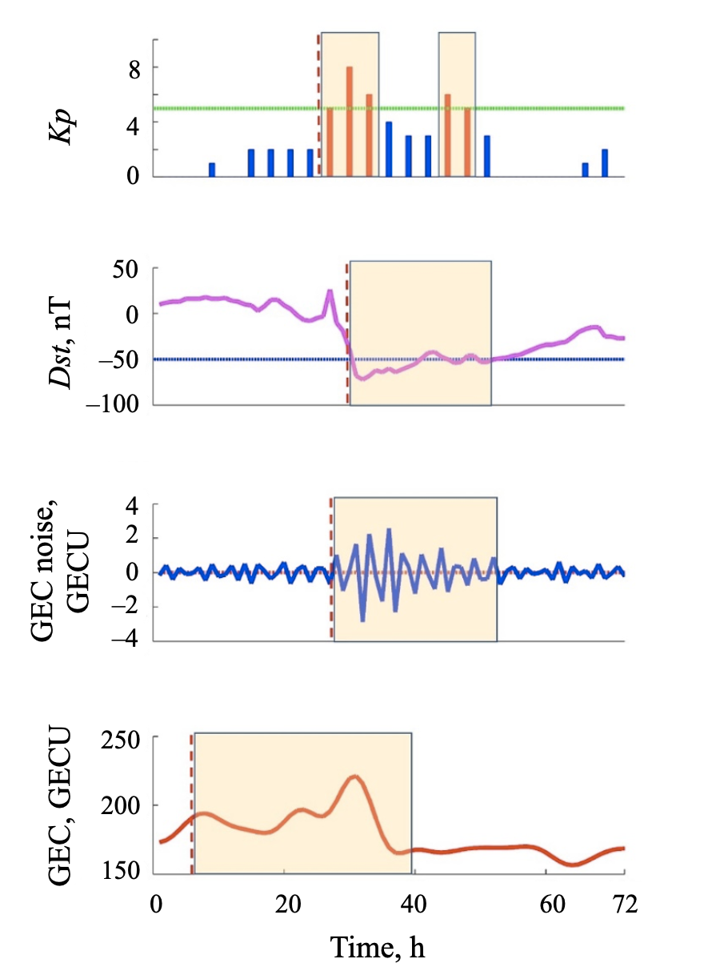

Fig. 3

<…>

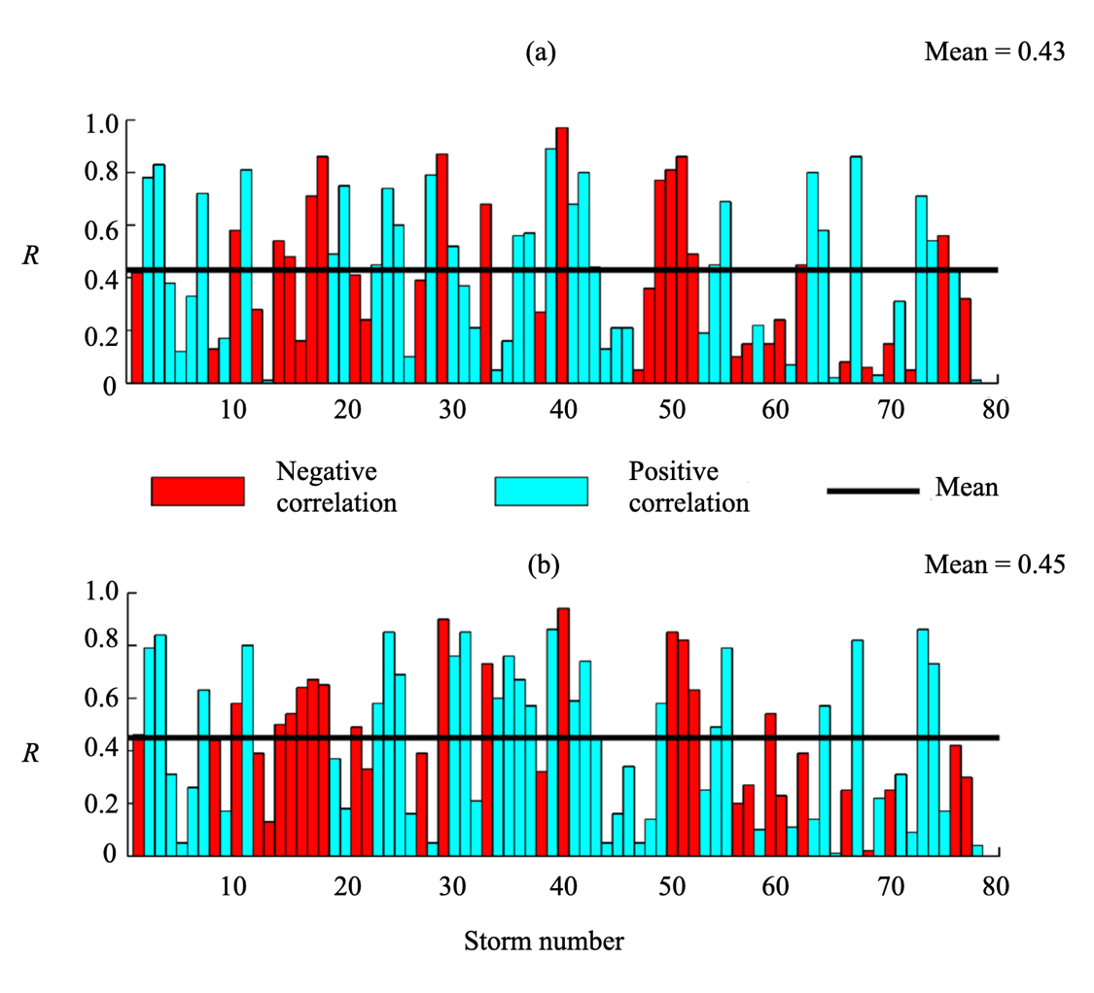
Fig. 5
<…>

