Improving the Catalytic Stability of Ni/TiO₂ for Ethanol Guerbet Condensation: Influence of Second Metal Component

Shuaiqi Li(https://orcid.org/0000-0006-3034-6315)ª, Xiaoxu Han(https://orcid.org/0000-0004-3016-6317)ª, Hualiang An(https://orcid.org/0000-0001-3034-6655)^{a,}*, Xinqiang Zhao(https://orcid.org/0000-0002-3033-3156)^{a,}** and Yanji Wang(https://orcid.org/0000-0108-3034-555X)ª

ªHebei Provincial Key Lab of Green Chemical Technology and High Efficient Energy Saving, National-Local Joint Engineering Laboratory for Energy Conservation in Chemical Process Integration and Resources Utilization, School of Chemical Engineering and Technology, Hebei University of Technology, Tianjin, 300000 China
*e-mail: anhl@hebut.edu.cn
**e-mail: zhaoxq@hebut.edu.cn
Abstract—Ethanol Guerbet condensation (EGC) is a green process for preparing n-butanol and the development of highly effective solid catalysts is still the bottleneck of this reaction. In this work, a series of multifunctional catalysts Ni–X/TiO₂ (X = Ru, Pt, Ir, Au, Cu, Mn, Co, Fe) were prepared by a co-impregnation method to improve the catalytic performance, especially the stability. It was found that the addition of the second metal component changed the acidity and alkalinity of Ni/TiO₂ catalyst. What is more, acid site number affected ethanol conversion while alkali site number affected n-butanol selectivity. Among the Ni–X/TiO₂ catalysts, Ni–Cu/TiO₂ showed the best catalytic performance. The effects of preparation conditions on the catalytic performance of Ni–Cu/TiO₂ were investigated and the results showed that the suitable preparation conditions were as follows: a Ni/Cu mass ratio of 59 : 1, a Ni–Cu loading of 12.5 wt %, a calcination temperature of 450°C, a calcination time of 2 h, a reduction temperature of 400°C, and a reduction time of 4 h. At a 10 wt % of catalyst loading, a reaction temperature of 210°C and a reaction time of 10 h, the ethanol conversion and the selectivity of n-butanol were 47.9 and 44.4%, respectively. Moreover, the stability of Ni–Cu/TiO₂ catalyst was greatly improved due to the interaction between Ni and Cu as compared with the Ni/TiO₂ catalyst: the catalytic activity of Ni–Cu/TiO₂ did not decline significantly for reuse in three cycles.

Keywords: ethanol, n-butanol, Guerbet reaction, Ni–Cu/TiO₂ catalyst, stability

Abbreviations and notation: EGC, ethanol Guerbet condensation; EO, ethanol; BO, n-butanol; EB, 2-ethylbutanol; HO, 1-hexanol; EH, 2-ethyl-1-hexanol; X, conversion; Y, yield; S, selectivity.

Introduction
A decline of crude oil reserves and an increase in environmental pollution are driving academia and industry to pay more attention to the production of liquid biofuel. Bioethanol has been widely blended into gasoline based on the above two concerns. Unlike ethanol, the energy density and vaporization heat of n-butanol are close to those of gasoline, so it can be mixed with gasoline freely without need of changing vehicle engine. Therefore, n-butanol is called an advanced biofuel with good environmental benefits [1]. The traditional industrial production of n-butanol is based on low-pressure carbonylation process and biological fermentation process, suffering from severe reaction conditions or low productivity. In contrast, the synthesis of n-butanol by Ethanol Guerbet condensation (EGC) is characterized by a short process flow, a clean reaction process and a low production cost [2]. In addition, a series of derivatives including esters and ethers have great application value and can be used in a wide field of industries including petrochemicals, agriculture, medicine, and cosmetics [3, 4].
Based on the mechanism of reaction, EGC is performed in three steps: ethanol dehydrogenation to acetaldehyde, acetaldehyde aldol self-condensation to 2-crotonaldehyde, and 2-crotonaldehyde hydrogenation to n-butanol [5]. So, the catalysts used in EGC should possess the ability to catalyze dehydrogenation/hydrogenation and aldol condensation reactions, i.e, they should be multifunctional catalysts. Wu et al. [6] used M–CeO₂/AC (M = Cu, Fe, Co, Ni, Pd) to catalyze EGC and found that Pd–CeO₂/AC was more effective. Furthermore, addition of Pd improved the stability of catalyst by decreasing carbon accumulation on catalyst surface. Chistyakov et al. [7] studied ethanol self-condensation reaction over Au–Ni/Al₂O₃ catalyst and found that adding a small amount of nickel could promote the dispersion of metallic gold. The synergetic effect of Au–Ni could inhibit the sintering of Au grains and improve the stability of catalyst. Zaccheria et al. [8] compared the catalytic performance of hydrotalcite material (HT) supported Ni, Cu, and Ni–Cu catalysts in EGC and found that Ni–Cu/HT had the highest catalytic activity and stability. They attributed the excellent performance of Ni–Cu/HT to the uniform dispersion of Ni–Cu, the formation of Ni–Cu alloy and lesser acidic sites in Ni/HT and Cu/HT catalysts. The authors of the present work [9] evaluated the catalytic performance of Ni/TiO₂ catalyst for EGC. The selectivity of C₄–C₈ alcohols reached up to almost 70% (41.4% of n-butanol) at nearly half conversion of ethanol at 210°C and 10 h. However, the reusability of Ni/TiO₂ catalyst was poor: ethanol conversion decreased from 49.2 to 36.2% while n-butanol selectivity decreased from 41.7 to 36.8% in the third run. ICP analysis of the catalyst before and after use showed that Ni/TiO₂ catalyst deactivated due to a loss of Ni during the reaction process.
In this work, a series of multifunctional catalysts Ni–X/TiO₂ (X = Ru, Pt, Ir, Au, Cu, Mn, Co, Fe) were prepared by a co-impregnation method to improve the catalytic performance, especially the reusability of Ni/TiO₂ catalyst. The effects of the addition of the second metal component on the catalytic performance of Ni/TiO₂ catalysts were analyzed. After Ni–Cu/TiO₂ catalyst was screened out, the effects of preparation conditions on its catalytic performance were investigated, and then the catalytic stability of Ni–Cu/TiO₂ was inspected.

Experimental

Preparation of Ni–Х/TiO₂ Catalyst
Preparation of Ni–Cu/TiO₂ catalyst was taken as an example. TiO₂ precursor was prepared by a sol–gel method with butyl titanate as the titanium source. TiO₂ was obtained by calcinating the TiO₂ precursor at 450℃ for 1 h [10]. Ni–Cu/TiO₂ catalyst was prepared by a co-impregnation process. The resultant solid was calcined in a muffle furnace at 450℃ for 2 h and reduced at 400℃ for 4 h in a mixture of hydrogen and nitrogen with a volume ratio of $V_{N_{2}}$ : $V_{H_{2}}$ = 60 : 40 to obtain Ni–Cu/TiO₂ catalyst [9]. The preparation of other Ni–Х/TiO₂ catalysts was similar to that of Ni–Cu/TiO₂.

Characterization of Catalyst
The specific surface, pore volume and pore diameter of samples were measured on a Micromeritics ASAP2020M+C specific surface area and porosity analyzer. The specific surface was calculated by BET method and the pore volume and pore diameter of samples were calculated by BJH method. The phase analysis of samples was performed on a Rigaku D/max-2500 X-ray diffractometer. The metal contents of samples were analyzed by a PerkinElmer's Optima 7300V inductively coupled plasma atomic emission spectrometer. Determination of acidity (NH₃-TPD), alkalinity (CO₂-TPD) and reduction performance (H₂-TPR) of samples were performed on a Micromeritics AutoChem Ⅱ-2920 type chemical adsorption instrument. The electron binding energy of each element on the catalyst surface was measured using a Kratos Axis Ultra DLD photoelectron spectrometer and calibrated by the standard value Е(C1s) = 284.6 eV. The specific operations for the characterization of catalyst were described in our previous articles [10, 11].

EGC Operation Procedure
EGC was performed in a 100 mL stainless steel autoclave lined with teflon. A typical operation procedure has been described in the previous study [9]. The liquid products (condensable components) were quantitatively analyzed by a Shimazu GC-2018 gas chromatograph equipped with a flame ionization detector (FID) operated at 280℃. The components were quantitatively calculated by the internal standard method with toluene as the internal standard. The gas products were quantitatively analyzed on the same gas chromatograph equipped with a thermal conductivity detector (TCD) controlled at 150℃. The external standard method was used for quantitative calculation.
The conversion of ethanol, the yield and selectivity of n-butanol were calculated as follows:
$X_{EO}=\frac{W_{EO}^{0}-W_{EO}}{W_{ЕO}^{0}}$,
$Y_{BO}=\frac{W_{BO}}{W_{ЕO}^{0}×0.804}$,
$S_{BO}=\frac{Y_{BO}}{X_{EO}}$,

where, W_{BO} is the amount of n-butanol formed (g), W_{EO} is the amount of ethanol left (g), W⁰_{EO} is the amount of ethanol charged (g). X is the conversion, Y is the yield, and S is the selectivity. 0.804 is the mole of n-butanol formed per mole of ethanol converted.

Results and discussion

Screening of Second Metal Components
Ni–X/TiO₂ (X is Ru, Pt, Ir, Au, Cu, Mn, Co or Fe) catalysts with a Ni/X mass ratio of 39 : 1 and a Ni–X loading of 12.0 wt % was prepared by calcination at 450°C for 2 h and reduction at 400°C for 4 h under an atmosphere of $V_{H_{2}}$ : $V_{N_{2}}$ = 40 : 60. The catalytic performances of Ni–X/TiO₂ catalysts in EGC were evaluated and the results are shown in Fig. 1. Ethanol conversion was higher over the Ni–X/TiO₂ catalysts with noble metal (Ru, Pt, Ir, Au) than that over catalysts with non-noble metal (Cu, Mn, Co, Fe). However, the selectivity of n-butanol and total alcohols over Ni–Pt/TiO₂, Ni–Ir/TiO₂, Ni–Au/TiO₂, Ni–Co/TiO₂, Ni–Fe/TiO₂ and Ni–Mn/TiO₂ was smaller than that over Ni/TiO₂ catalyst, and the autogenous pressures in the autoclave was respectively 4.2, 4.9, 4.2, 4.0 and 4.1 MPa, being more than that (3.6 MPa) over Ni/TiO₂ catalyst. This indicated that the addition of these six metals not only improved hydrogenation performance, but also promoted the ability to break C–C bonds, leading to the formation of more gas by-products. When the second metal was copper, the selectivity of n-butanol and total alcohols was the highest, so copper was selected as the second metal.
<…>

Effect of Preparation Conditions on Catalytic Performance of Ni–Cu/TiO₂
The influence of preparation conditions (Ni/Cu mass ratio, Ni–Cu loading, calcination temperature, calcination time, reduction temperature, and reduction time）on the catalytic performance of Ni–Cu/TiO₂ catalyst was investigated and the results are shown in Table 2. As the Ni/Cu mass ratio decreased, ethanol conversion decreased but n-butanol selectivity increased while the yield of n-butanol decreased first and then levelled off. With increasing Ni–Cu loading, ethanol conversion levelled off first and then decreased, n-butanol selectivity increased, and n-butanol yield increased first and then decreased. As the calcination temperature increased, the conversion of ethanol increased while the selectivity of n-butanol, yield of n-butanol and selectivity of total alcohols increased first and then decreased. The effect of calcination temperature on the selectivity of n-butanol was generally insignificant. With the extension of calcination time, the conversion of ethanol, the selectivity of n-butanol, the yield of n-butanol and the selectivity of total alcohols all increased first and then decreased. When the reduction temperature increased, ethanol conversion decreased while n-butanol selectivity, n-butanol yield and the selectivity of total alcohols increased first and then decreased. As for the byproducts, the selectivity of 2-ethylbutanol decreased while the selectivity of n-hexanol and 2-ethylhexanol did not change much. With the extension of reduction time, the conversion of ethanol, the selectivity of n-butanol, the yield of n-butanol and the selectivity of total alcohols increased first and then decreased. As a result, the suitable preparation conditions for Ni–Cu/TiO₂ were as follows: a Ni/Cu mass ratio of 59 : 1, a Ni–Cu loading of 12.5 wt %, a calcination temperature of 450°C, a calcination time of 2 h, a reduction temperature of 400°C and a reduction time of for 4 h
<…>

Reusability of Ni–Cu/TiO₂ Catalyst
<…>
After the completion of reaction, Ni–Cu/TiO₂ catalyst was recovered and washed three times with anhydrous ethanol. Then the recovered catalyst was dried at 100℃ and finally reduced for 4 h at 400℃ in a mixture of hydrogen and nitrogen with a volume ratio of $V_{H_{2}}$ : $V_{N_{2}}$ = 40 : 60. The regenerated Ni–Cu/TiO₂ catalyst was reused in EGC reaction under the suitable conditions (a weight percentage of catalyst of 10%, 210℃, 10 h) and the results are showed in Fig. 3. The catalytic performance decreased gradually with the reuse of catalyst, but the degree of decrease was less obvious than that over Ni/TiO₂ catalyst. After three cycles, ethanol conversion over Ni–Cu/TiO₂ decreased from 47.9 to 42.0% (a decrease of 5.9%), and n-butanol selectivity decreased from 44.4 to 42.4% (a decrease of 2%). In contrast, after the third use, ethanol conversion over Ni/TiO₂ catalyst decreased from 49.2 to 36.2% (a decrease of 13%), and n-butanol selectivity decreased from 41.7 to 36.8% (a decrease of 4.9%). So, the reusability of Ni–Cu/TiO₂ catalyst was greatly improved compared with Ni/TiO₂ catalyst. Furthermore, after 5 cycles, ethanol conversion over Ni–Cu/TiO₂ catalyst decreased from 47.9 to 41.7% (a decrease of 6.2%), and n-butanol selectivity decreased from 44.4 to 37.6% (a decrease of 6.8%). The ICP analysis result (Table SI-5) showed that metallic nickel content decreased from 12.3 to 11.1% (a decrease of 1.2%) after Ni–Cu/TiO₂ catalyst was reused for 4 times. Note that after the third use of Ni/TiO₂, metallic nickel content decreased from 12.0 to 9.8% (a decrease of 2.2%) indicating that the interaction between copper and nickel can effectively inhibit the loss of metallic nickel and improve the catalyst reusability.

Conclusions
(1) Among the bimetallic catalysts Ni–Х/TiO₂ (Х = Ru, Pt, Ir, Au, Cu, Mn, Co or Fe), Ni–Cu/TiO₂ showed the best catalytic performance. CO₂-TPD and NH₃-TPD measurement results indicated that the addition of the second metal component changed the acidity and alkalinity of Ni/TiO₂. The number of acid sites affected ethanol conversion, and the number of alkali sites affected n-butanol selectivity.
(2) The suitable preparation conditions for Ni–Cu/TiO₂ were as follows: a Ni/Cu mass ratio of 59 : 1, a Ni–Cu loading of 12.5 wt %, a calcination temperature of 450°C, a calcination time of 2 h, a reduction temperature of 400°C, and a reduction time of 4 h.
(3) The selectivity of n-butanol reached up to 44.4% at an ethanol conversion of 47.9% under the conditions of a catalyst dosage of 10 wt %, a reaction temperature of 210℃, and a reaction time of 10 h. Compared with Ni/TiO₂ catalyst, the reusability of Ni–Cu/TiO₂ catalyst was greatly improved due to the interaction between copper and nickel.

SUPPLEMENTARY Information
The supporting information includes NH₃-TPD and CO₂-TPD profiles of Ni–Х/TiO₂ catalysts, XRD patterns of Ni–Cu/TiO₂ samples with different Ni/Cu mass ratios, Ni2p and Cu2p XPS spectra of Ni–Cu/TiO₂ with different Ni/Cu mass ratios, textural properties of Ni–Cu/TiO₂ catalysts with different metal loadings, XRD patterns of Ni–Cu/TiO₂ samples with different calcination temperature, textural properties of Ni–Cu/TiO₂ catalysts with different calcination time, textural properties of Ni–Cu/TiO₂ catalysts with different reduction time, Ni–Cu/TiO₂ catalyzed ethanol Guerbet reaction and ICP analysis of nickel and copper contents in Ni–Cu/TiO₂ before and after reaction.
The online version contains supplementary material available at https://doi.org/[DOI].

FUNDING
This work was supported by National Natural Science Foundation of China (grants 21978066 and 21476058), Key Program of the Natural Science Foundation of Hebei Province (B2020202048), Basic Research Program of Hebei Province for Natural Science Foundation and Key Basic Research project (18964308D), and Natural Science Foundation of Hebei Province (B2018202220).

References
1. Amrita Chatterjee, Xijun Hu, and Frank Leung-Yuk Lam, Catal. Today, 2018, vol. 314, p. 137. https://doi.org/10.1016/j.cattod.2018.01.018
2. Benito, P., Vaccari, A., Antonetti, C., Licursi, D., Schiarioli, N., Rodriguez-Castellon, E., Galletti, A., and Maria, R., J. Cleaner Prod., 2019, vol. 209, p. 1614.
<…>
13. Legrand, J., Gota, S., Guittet, M.J., and Petit, C., Langmuir, 2002, vol. 18, p. 4131. https://doi.org/10.1021/la0117247
<…>

TABLES
<…>
Table 3. Electron binding energy (eV) of nickel and copper species in Ni–Cu/TiO₂ catalysts with different Ni/Cu weight ratios
Ni : Cu weight raio | Ni²⁺ |  |  |  | Ni⁰ | Cu²⁺ | Cu⁺ | Cu⁰
119:1 | 855.1 | 860.5 | 872.4 | 879.2 | 852.0 | 942.7 | N/A | 933.3 | 952.7
59:1 | 854.8 | 860.5 | 872.8 | 879.2 | 851.8 | N/A | 939.3 | 933.5 | 952.7
39:1 | 854.8 | 860.3 | 872.6 | 879.3 | 851.6 | 941.7 | N/A | 933.8 | 952.8
29:1 | 855.0 | 860.0 | 872.8 | 878.8 | 851.4 | 942.0 | N/A | 934.1 | 952.9
19:1 | 854.7 | 860.2 | 872.2 | 878.8 | 851.0 | 942.3 | N/A | 934.2 | 952.9

Figure Captions
Fig. 1. Catalytic performance of Ni–X/TiO₂ catalysts for EGC. Reaction conditions: m_{cat} : m_{ethanol} = 10 : 100, T = 210℃, t = 10 h.
Fig. 2. H₂-TPR curves of catalysts Ni/TiO₂ (a), Cu/TiO₂ (b) and Ni–Cu/TiO₂ (c).
Fig. 3. Reusability of Ni–Cu/TiO₂ catalyst. Reaction conditions: m_{cat} : m_{ethanol} = 10 : 100, T = 210℃, t = 10 h.

FIGURES

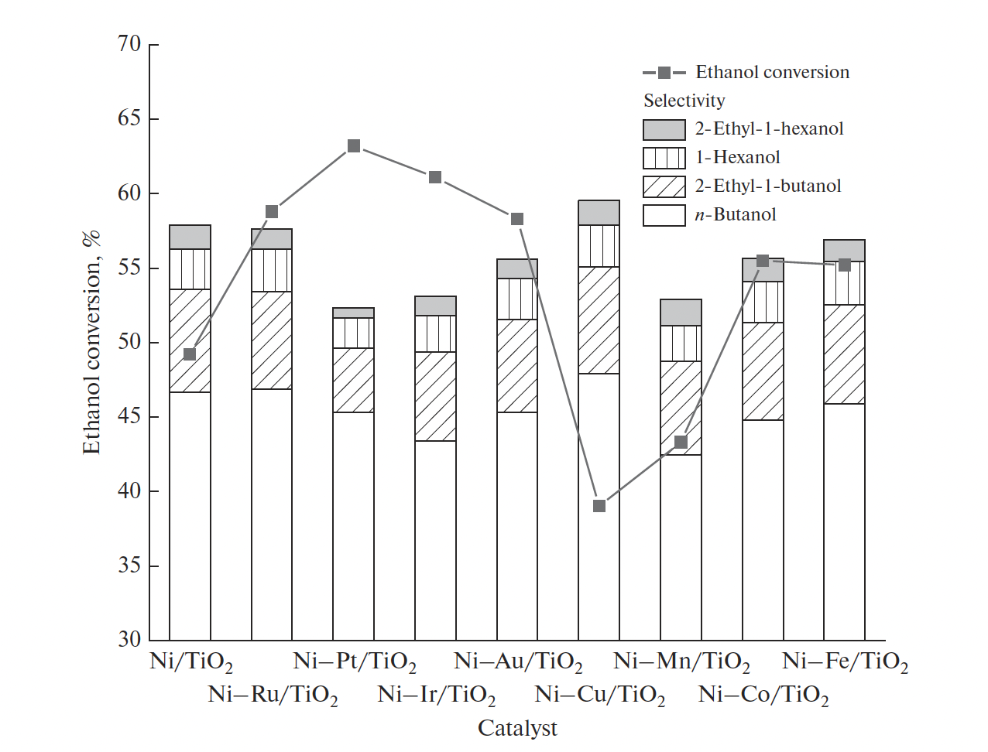
Fig. 1.
<…>
LIST OF SUPPORTING INFORMATION

Fig. SI-1. NH₃-TPD (a) and CO₂-TPD (b) profiles of Ni–X/TiO₂ catalysts: (1) Ni–Fe/TiO₂; (2) Ni–Co/TiO₂; (3) Ni–Mn/TiO₂; (4) Ni–Cu/TiO₂; (5) Ni–Ir/TiO₂; (6) Ni–Au/TiO₂; (7) Ni–Pt/TiO₂; (8) Ni–Ru/TiO₂.
Fig. SI-2. XRD patterns of Ni–Cu/TiO₂ samples with different Ni/Cu mass ratios: (1) 119 : 1; (2) 59 : 1; (3) 39 : 1; (4) 29 : 1; (5)19 : 1.
<…>

